**WORKSHEET 2**

**Student Name:** Vivek Kumar **UID:** 21BCS8129

**DOMAIN CAMP:** 16-01-2023 to 28-01-2023 **Section/Group:** DWWC-77

**Subject Name:** IT Skills (DSA)

# Question 1. ROLLAR COSTER

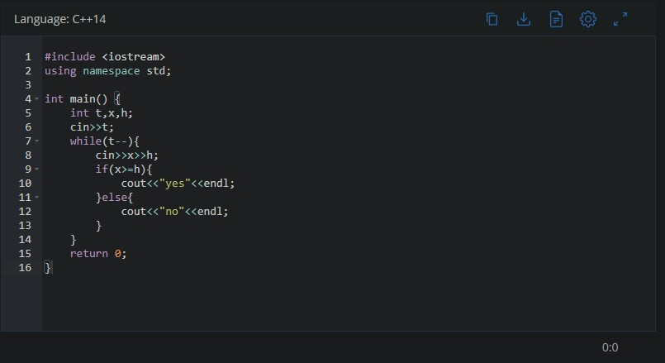

**SOLUTION:**

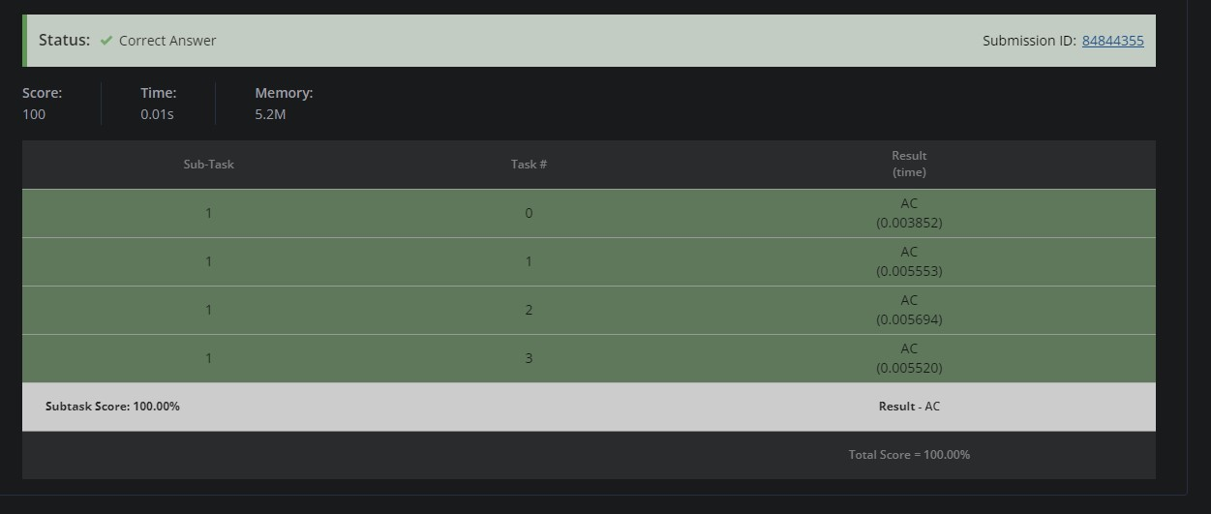

# CHEF OF THE YEAR

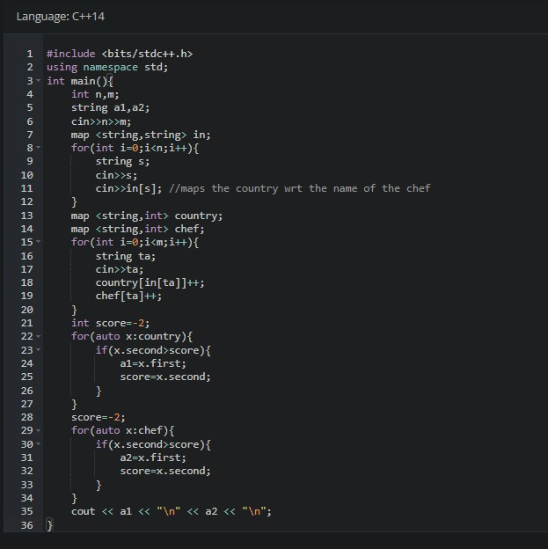

**SOLUTION:**

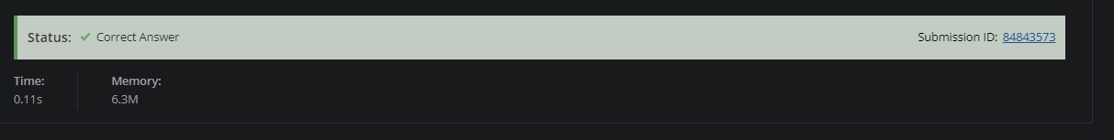

# DETERMINE THE WEATHER

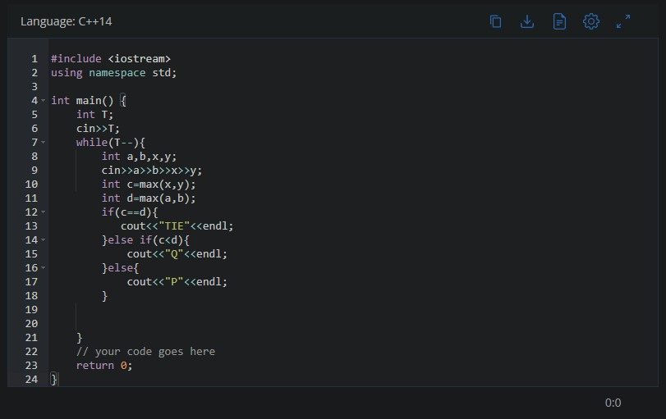

**SOLUTION:**

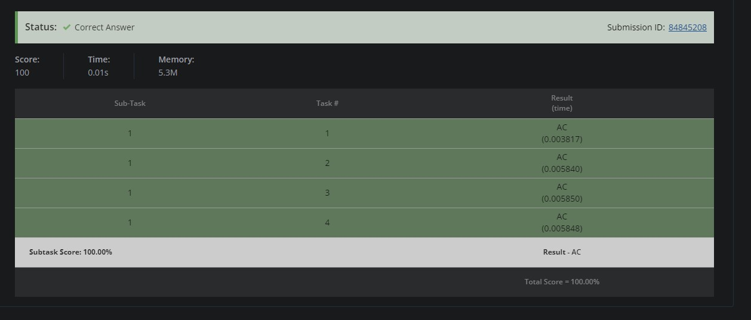

# DISTINCT PAIRS

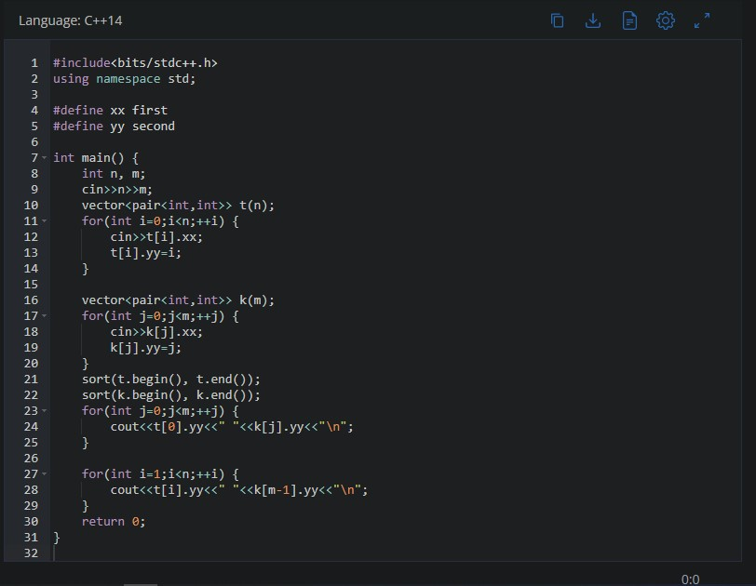

**SOLUTION:**

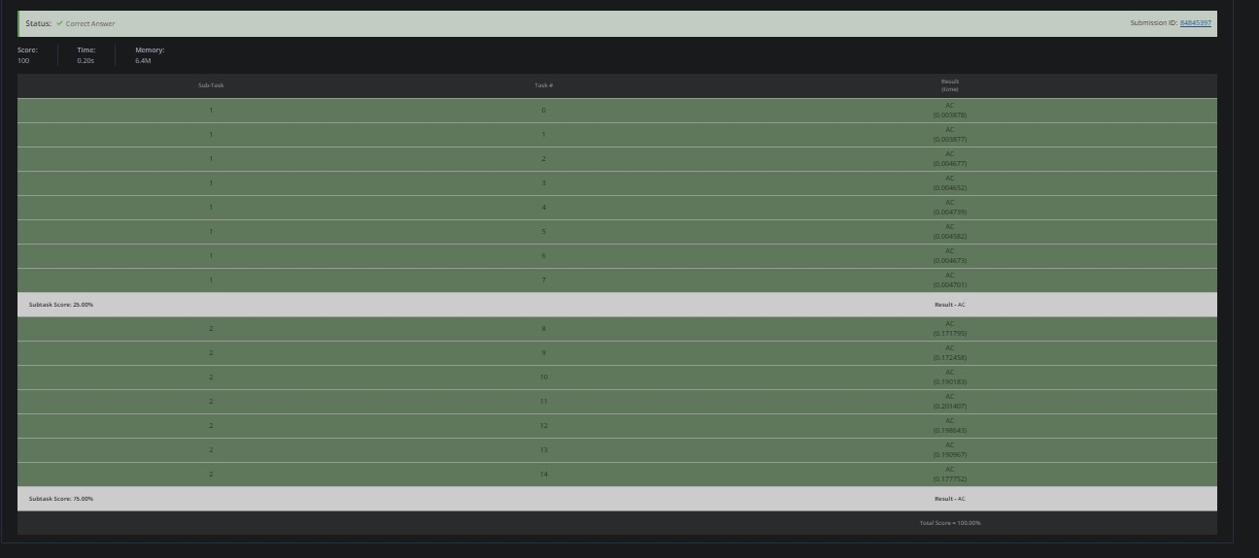

# CHEF AND BRAIN SPEED

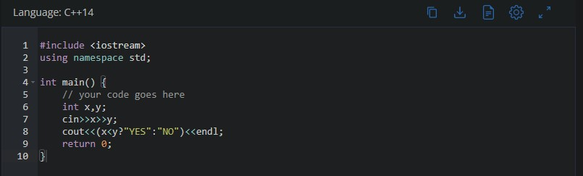

**SOLUTION:**

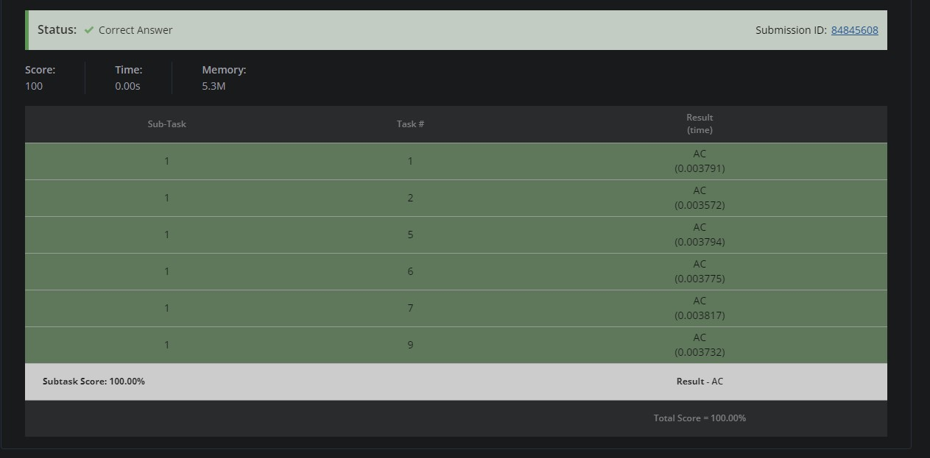

# JUMP GAME

